*Anne Frank*

Historical Connection Notes: Propaganda

**Persuasion** is: *A means of persuading someone to do or believe something; an argument or inducement*

**Propaganda** is: i*nformation, especially of a biased or misleading nature, used to promote or publicize a particular political cause or point of view.*

In other words... a message that tries to persuade you to do or think in a certain way using **exaggeration**, sometimes even to the point of **lying**.

**What does this have to do with Anne Frank?**

Governments on both sides of the war use(d) propaganda to gain the support of their people.

Understanding "propaganda" might help explain how and why Hitler gained support, even though his policies were so difficult for us to understand today...

**Hitler's use of propaganda...**

German propaganda was extremely important to the course of World War II. By taking control of the media and only printing or broadcasting Nazi material, the Reich was able to effectively flood Germany with its propaganda. This... created one of the most potent barrages of wartime propaganda in history.

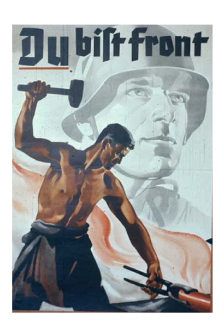

Examples of authentic propaganda posters from Nazi Germany during WWII:

🡨 "YOU are the front!" emphasizing the importance of manufacturing to support the war effort.

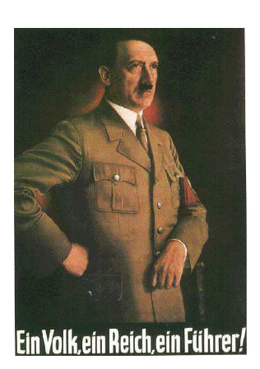🡨 This poster, which reads “One People, One Reich, One Führer,” was a piece of one of the most important parts of the German propaganda. By establishing a rudimentary worship for the Führer (Leader) that was almost mythological, Adolf Hitler was established as the absolute head of the government and to some a semi-deity. This inspired the public to work harder and do more for the Reich, having been convinced by the Führer propaganda that the war was a sort of holy quest or crusade. The Führer worship also helped instill pride in Germany and the Reich among the German population... This not only glorified the Reich, but also persuaded many people to further follow its commands. This helped in the war effort and also generated pride in the German nation and the Reich.

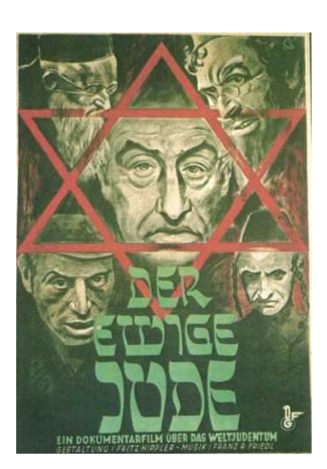

🡨 Posters like this one, which advertises the Nazi film “The Eternal Jew,” served to dehumanize the German Jews. The film “The Eternal Jew” itself compares the Jewish people to rats. By dehumanizing Jews, the Nazi leaders began to prepare for Hitler’s “Final Solution.” The Nazi leaders knew that when the deportations began it would be much easier for the German people to watch friends and neighbors shipped away if they associated them with rats or with age-old stereotypes about cheating with money. The propaganda was able to play off the existing racial difficulties in Germany has well as to enhance the original nationalistic pride of the German people that they were somehow chosen or holy. Anti-Semitic propaganda was common in wartime Germany, and often depicted Jews in league with communists or another hated group causing harm to Germans.

**Was Germany the only country to use propaganda?**

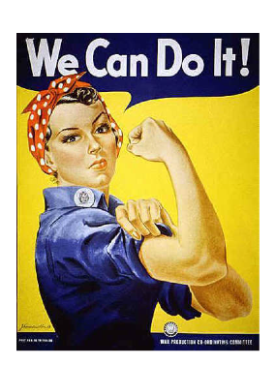

Examples of propaganda posters for United States during WWII:

🡨"Rosie the Riverter" became a very popular poster. It encouraged women to go to work to help support manufacturing while the men were away.

The Nazis were not the only government guilty of using racist stereotypes in their propaganda. The US also played into the fears and prejudices of its people. Many posters encouraged Americans to fear and distrust people of Japanese descent, and the fear that spies were everywhere... even possibly their friends and neighbors.

